Customer Response Videos

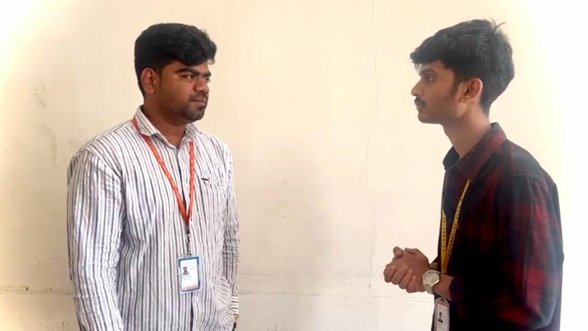
https://drive.google.com/file/d/1psA4p9WtsN-2Wdi__XgCbcOpI-6AKw5s/view?usp=drivesdk


https://drive.google.com/file/d/1fnOuvgeef11EPrt89Xi3XZl94ixChCIa/view?usp=drivesdk
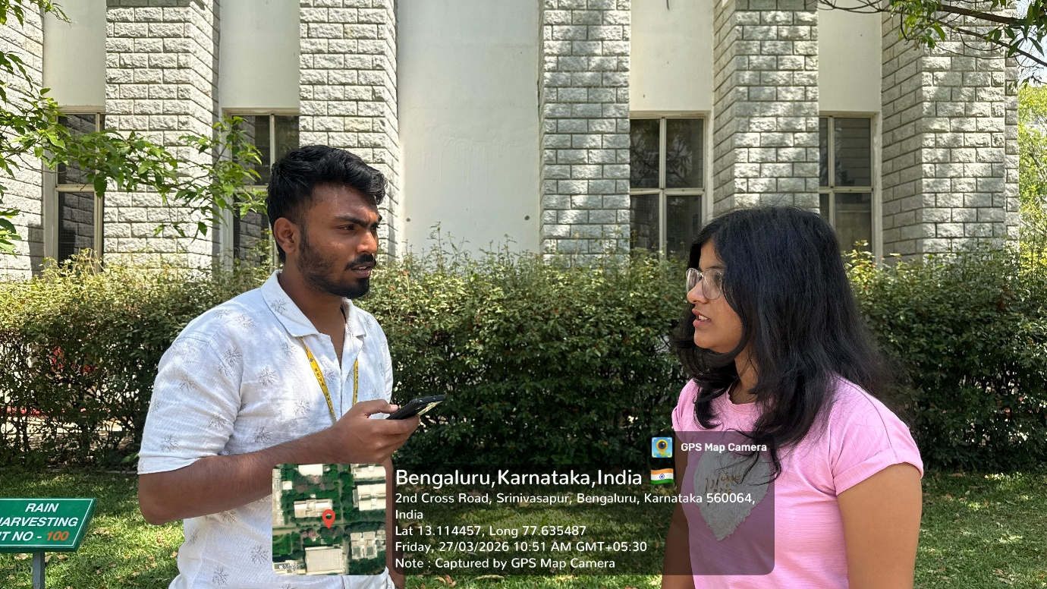
https://drive.google.com/file/d/1gKk39-FRL-1Nd5SbvpgAO6eTokjpFUVY/view?usp=drivesdk

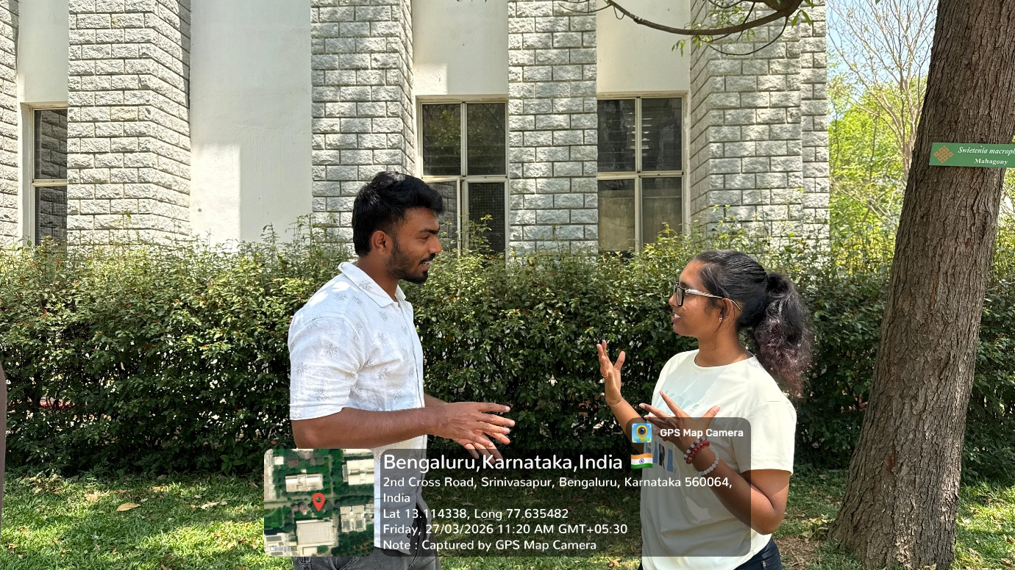
https://drive.google.com/file/d/1fW3yUvcIPZa1wHVI-wRkAc9L7HqZmTfX/view?usp=drivesdk

